Ecuador - mining projects, oil blocks, indigenous territory

19

Name of project Company Minerals
6

8

7

3
4 10
24 11
17 12

9
15

5 18

20

Intangible area

Yasuni national park
1 Fruta del Norte
2 Mirador
3 Río Blanco
4 Quimsacocha
5 Pananza-San Carlos
6 Junín
7 Curipamba
8 Rumiñahui
9 Méndez
10 Gaby
11 Shyri
12 Santiago
13 Caña Brava y Monterrey
14 Macará
15 Orro Tierra
16 Orro Tierra 2
17 Los Cangrejos
18 Warintza
Kinross Ecuacorriente IMC
Iamgold Ecuacorriente Enami
Curimining - Salazar Resources Curimining - Salazar Resources Curimining - Salazar Resources IMC
Cornerstone Cornerstone Cornerstone Cornerstone Monterra Monterra
ODIN Mining Ecuador
Lowell Mineral Exploration
Gold
Copper, Gold
Gold Gold Copper Copper
Copper, Zinc
Gold
Copper, Molybdenum
Gold, Silver
Gold Gold Gold Gold Gold
Gold, Silver, Copper, Molybdenum
Gold
Copper, Molybdenum

13 16
23 2
25 1
14 21
Indigenous territory

Oil blocks

Mining concessions

Mining projects

19 Santiago
20 Huambuno
21 Conquime
22 Isimanchi
23 Zaruma Gold

Bira Enami Enami Enami
Curimining - Salazar Resources

Gold, Silver
Gold Silver Gold
Copper, Zinc

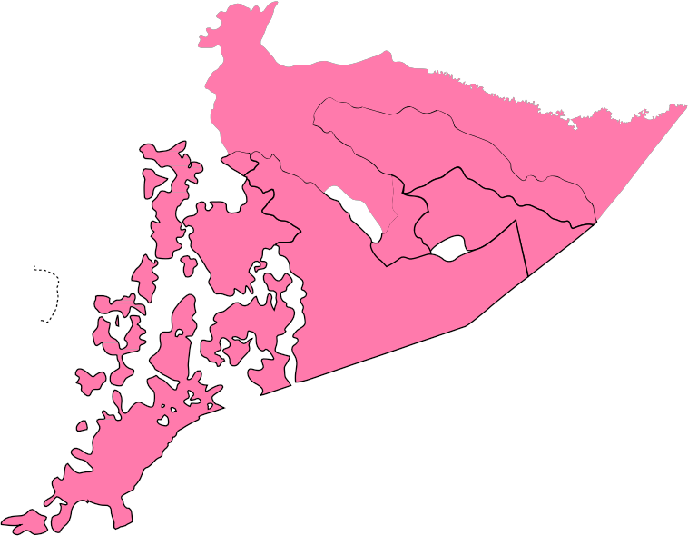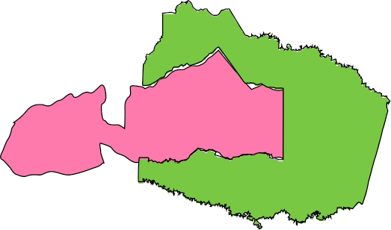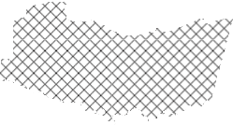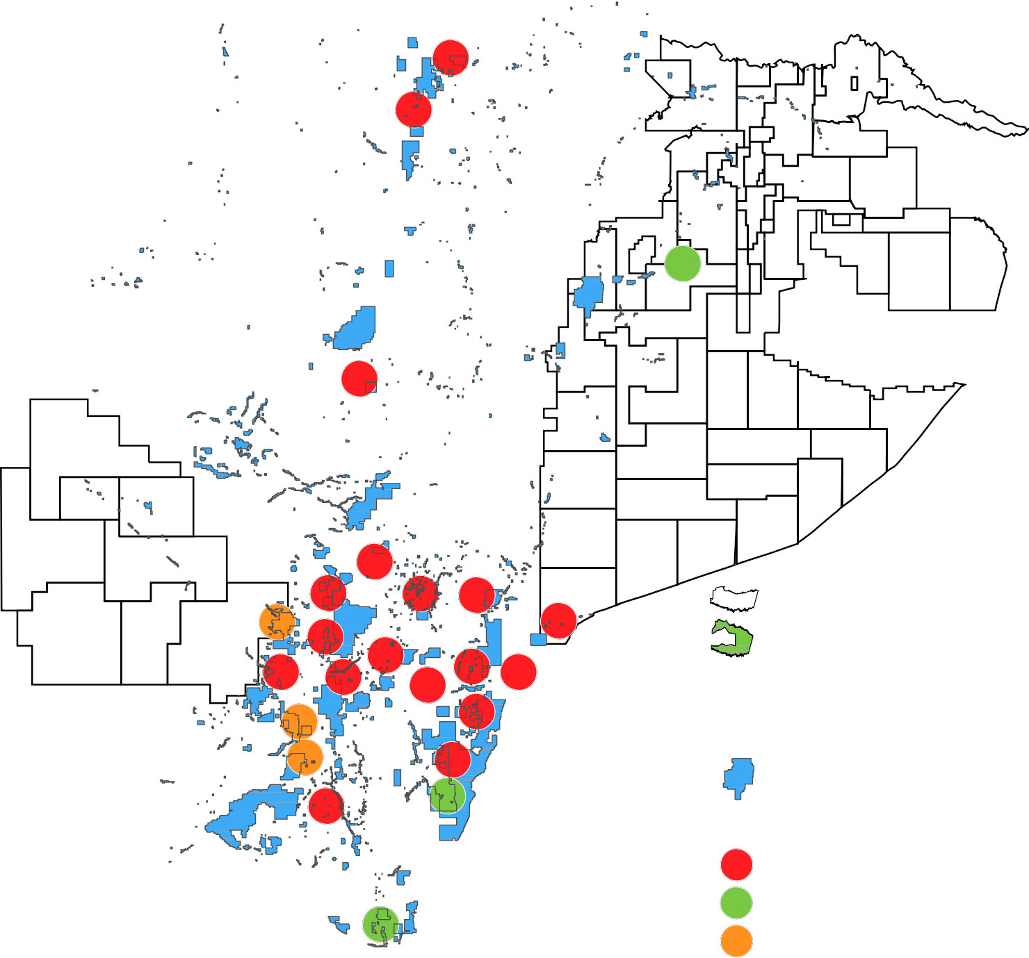x x
22 x

Large-scale mining National projects Small-scale mining
24 Bella Rica
25 Zaruma
Dynasty - Elipe
Coop. Bella Rica
Gold, Silver
Gold, Silver

